Module 8 Portfolio Project
Programming III
CSC450-1 Fall 2025 Session C
Dr. Bindu George

Grant Brosovich
11/02/2025

Source Code (Java):
package project_portfolio_Java;

import java.util.concurrent.locks.ReentrantLock;

public class ConcurrentCounter {
private static final ReentrantLock consoleLock = new ReentrantLock();

private static void countUp(int limit) {
long startTime = System.currentTimeMillis();

for (int i =1; i <= limit; i++) {
consoleLock.lock();
try {
System.out.println("Counting up: " + i);
} finally {
consoleLock.unlock();
}
try {
Thread.sleep(100);
} catch (InterruptedException e) {
Thread.currentThread().interrupt();
return;
}
}

long endTime = System.currentTimeMillis();
double elapsed = (endTime - startTime) / 1000.0;

consoleLock.lock();
try {
System.out.printf("Thread 1 completed in %.3f seconds. %n", elapsed);
} finally {
consoleLock.unlock();
}
}
private static void countDown(int start) {
long startTime = System.currentTimeMillis();

for (int i = start; i >= 0; i--) {
consoleLock.lock();
try {
System.out.println("Counting Down: " +i);
} finally {
consoleLock.unlock();
}

try {
Thread.sleep(100);;
} catch (InterruptedException e) {
Thread.currentThread().interrupt();
return;
}
}

long endTime = System.currentTimeMillis();
double elapsed = (endTime - startTime) / 1000.0;

consoleLock.lock();
try {
System.out.printf("Thread 2 completed in %.3f seconds.%n", elapsed);
} finally {
consoleLock.unlock();
}
}

public static void main(String[] args) {
System.out.println("Starting concurrent counting exercise...");

Thread threadUp = new Thread(() -> countUp(20));
Thread threadDown = new Thread(() -> countDown(20));

threadUp.start();
threadDown.start();

try {
threadUp.join();
threadDown.join();
} catch (InterruptedException e) {
Thread.currentThread().interrupt();
}
System.out.println("Both threads have finished execution.");
}
}

Running Program Snapshot (Java):
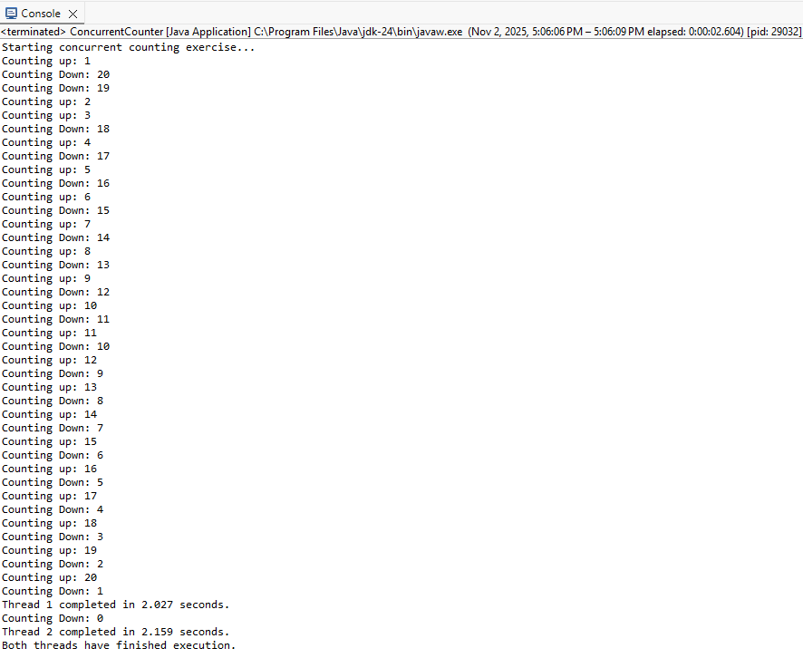

Source Code (C++):
#include <iostream>
#include <thread>
#include <chrono>
#include <mutex>

using namespace std;
using namespace std::chrono;

std::mutex consoleMutex;

void countUp(int limit) {
auto startTime = high_resolution_clock::now();

for (int i = 1; i <= limit; ++i)
{
lock_guard<mutex> guard(consoleMutex);
cout << "Counting Up: " << i << endl;
this_thread::sleep_for(milliseconds(100));
}
auto endTime = high_resolution_clock::now();
duration<double> elapsed = endTime - startTime;

lock_guard<mutex> guard(consoleMutex);
cout << "Thread 1 (Count Up) completed in " << elapsed.count() << " seconds.\n";
}

void countDown(int start) {
auto startTime = high_resolution_clock::now();

for (int i = start; i >= 0; --i) {
lock_guard<mutex> guard(consoleMutex);
cout << "Counting Down: " << i << endl;
this_thread::sleep_for(milliseconds(100));
}

auto endTime = high_resolution_clock::now();
duration<double> elapsed = endTime - startTime;
lock_guard<mutex> guard(consoleMutex);
cout << "Thread 2 (COunt Down) completed in " << elapsed.count() << " seconds.\n";
}
int main() {
cout << "Starting concurrent counting exercise...\n";
thread t1(countUp, 20);
t1.join();
thread t2(countDown, 20);
t2.join();

cout << "Both threads have finished execution.\n";
return 0;
}

Running Program Snapshot (C++):
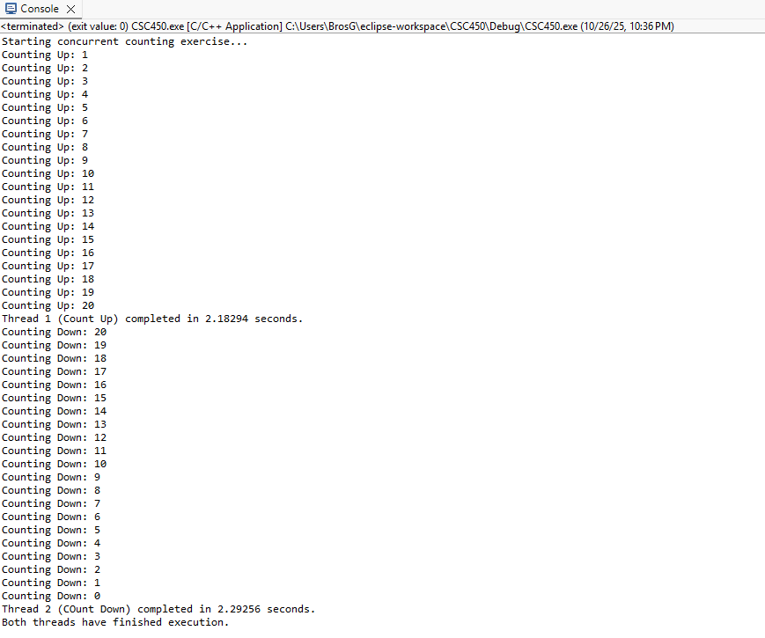

For this version of the concurrent application there are a few areas that will need particular focus to hurdle some performance and data security obstacles. Java implements thread creation and management in simple ways, but each stack generally consumes between 512 KB to 1 MB, with extreme dependence on the needs of the program running the thread and the resources it requires (Bouda, 2019). As more threads would be created and managed, different protocols may need to be implemented to increase performance optimization. If switching between threads occurs often then the CPU will store and save instances of those threads. Timing locks and precision could be affected by this so using modern mechanisms like ExecutorService could reduce those costs (Oracle, 2025). Through fixed thread sizing and control mechanisms built into the interface, the flexibility of custom locking and thread control is not available, but this service is robust enough to handle managing many threads and their queues (Dayananda, 2024). Another obstacle is the use of resources the program and functions need to execute. One resource is the console. Because of ReentrantLock, only one thread may utilize the console at a time. While this ensures the integrity of the output and keeps its utilization synchronized, it may create a bottleneck if multiple threads require access to it. Some mitigation strategies, one of which is implemented in this program, is to have finely tuned locking, to buffer data per thread to allow printing all at once, or to use asynchronous logging frameworks to handle those bottlenecks.
An obstacle surrounding data security is the use of Strings in Java. These objects are immutable which can lead to high memory usage because every time a string is concatenated, modified, or moved, then a new object is created and stored. Because the counter in the above program is writing a new string of “Counting up:” every iteration is saving a new object. Java must use garbage collection to remove unused Strings that can eventually create program pauses if there are long-running programs. Alongside this immutability and object retention, sensitive data may become compromised if not handled correctly. If access to logs or debugging is not restricted or handled effectively, those Strings that have been retained before garbage dump may be accessed by undesirable parties. A good avoidance practice is to avoid logging raw data but rather reference the variable names in order to complete any necessary logging actions. The last data related obstacle would be stack management and overflow issues with extremely long objects. If the counting program extended to an integer larger than 2,147,483,647, the program would encounter integer overflow. If this, or any numerical value, is expected to exceed this threshold, then using the long data-type would solve this problem.
In comprehensively analyzing this program for both C++ and Java programming languages we can better understand the performance, security, and reliability tactics that may provide advantages of one over the other. Firstly, we will examine performance tactics. When using multi-threading in Java, there is a lack of ability for in-depth and heavily customizable access to scheduling and lifestyle management but provides an advantage in predictability of behavior, ease of use, and portability across operating systems due to its use of the Java Virtual Machine (JVM) to communicate between the program, OS, and CPU. For example, in the Java version of this program, threads are instantiated using the ‘thread t1 = new Thread(new countUpTask());’ and ‘Thread t2 = new Thread(new CountDownTask();’ syntax. These threads rely on the JVM’s managed thread pool and memory model, allowing both to execute safely without explicit system-level handling of resources.
On the other hand, C++ provides advantages in low-level thread control, and possibly lower overhead during thread creation. In the C++ version, threads are created directly using the native ‘std::thread t1(countUp, 20);’ and ‘std::thread t2(countdown, 20);’ calls. This approach goves the developer explicit control over thread creation, synchronization, and lifecycle, but also exposes them to greater risk if threads are not properly joined or resources are mishandled. For the purposes of thread creation and management, Java is a better option for simpler and less intensive programs due to its built-in concurrency safety and runtime protection.
Within the same spectrum of performance, memory management between the two languages differ in how allocation and cleanup are handled. C++ requires manual memory management or a Resource Acquisition As Initialization (RAII) schema to ensure memory is properly released. In the provided C++ example, this is seen through the use of stack-based variables and explicit synchronization objects such as ‘std::mutex consoleMutex;’. Without proper cleanup, this approach risks memory leaks or even stack overflow if misuse occurs (Cardinal Peak, 2024). Conversely, Java provides automatic memory management through its Garbage Collection (GC), which handles cleanup for objects like ‘ReentrantLock lock = new ReentrantLock();’ and local variables after they fall out of scope. While this approach improves data safety and eliminates most manual cleanup errors, it can induce slight latency due to GC cycles that may pause thread execution.
In general, C++ can perform more efficiently, if all mechanisms for memory management, locking controls, and thread creation are implemented correctly. However Java provides safer and more reliable options for memory and thread management by design, even though it may execute more slowly and incur higher runtime overhead.
When discussing security between the two languages, data security and memory security are major topics of consideration. One defining factor of C++ is the ability to manipulate data and memory explicitly. For instance, the use of mutable ‘std::string’ objects within the ‘countUp()’ and ‘countDown()’ functions ‘cout << “Counting Up: “ << i << endl;’ provides flexibility but also exposes potential vulnerabilities such as buffer overflows or unintentional data exposure. In contrast, Java’s ‘System.out.println(“Counting Up: “ + i)’ call operates on immutable String objects, meaning that once ta string is created, it cannot be altered in memory. This characteristic reduces the risk of overwriting or tampering with string data at runtime. Java also handles data access across threads with more robust and defined locking mechanisms. In the Java version, synchronization is managed via the ReentrantLock object, which ensures mutual exclusion when printing to the console. This prevents two threads from interleaving outputs, while also protecting shared data from concurrent modification.
To achieve similar protections in C++, developers must explicitly use ‘std::mutex’ and ‘lock_guard<mutex>’ constructs, shown in the C++ program as ‘lock_guard<mutex> guard(consoleMutex);’. Failure to apply these correctly can result in race conditions or data corruption. While Java’s managed concurrency model minimizes these risks, C++ provides flexibility and precision for advanced systems requiring custom synchronization strategies.
With these security issues, data exposure and safety must be discussed. Both programs rely on developer’s best practices to ensure optimal data protection. However, Java inherently assists in data safety through its use of immutable String objects and automatic garbage collection, ensuring that once sensitive data (such as user identifiers or claim numbers) is no longer references, it becomes eligible for safe memory reclamation. In contrast, because C++ ‘std::strings’ are mutable, the stored data may remain accessible in memory even after being logically “cleared”, leaving it potentially vulnerable to memory scraping or overwriting attacks if not explicitly sanitized (TwinGate, 2024).

References:
Bouda, P. (2019, June 6). How much memory does a Java thread take?. DZone | Coding | Java. https://dzone.com/articles/how-much-memory-does-a-java-thread-take
Cardinal Peak. (2024, November 5). Raii introduction. Contract Engineering, Product Design & Development Company - Cardinal Peak. https://www.cardinalpeak.com/blog/raii-introduction
Dayananda. (2024, December 24). Overview of Executor Service in Java. Dev Community. November 2, 2025, https://dev.to/dayanandaeswar/overview-of-executor-service-in-java-40nm
Oracle. (2025, October 20). Interface ExecutorService. ExecutorService (Java Platform SE 8 ). https://docs.oracle.com/javase/8/docs/api/java/util/concurrent/ExecutorService.html
TwinGate. (2024, August 7). What is a Format String Attack? How It Works & Examples. TwinGate. November 2, 2025, https://www.twingate.com/blog/glossary/format%20string%20attack

Public GitHub Repository:

